 | 26.9.1 Editors - Properties Editor - Modifiers Properties Tab - Add Modifier menu
Table of content
Add Modifier menu 1
Search 1
Geometry Nodes 1
Data Browser 2
Edit box 2
Add Fake User 2
User 2
Add 2
Remove 2
Custom Inputs and Outputs 2
Unassigned (Catalogue) 2

Add Modifier menu
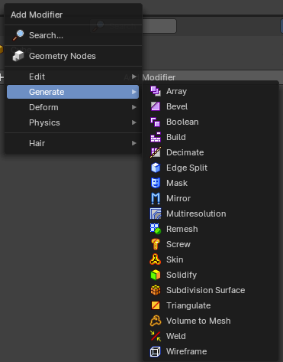
There are menu items in the add modifier menu that shows with all objects.

Search
Search for a specific modifier.

Geometry Nodes
Add a geometry nodes modifier.
This is usually done in the Geometry Nodes Editor.

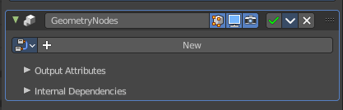
The geometry Nodes modifier adds a geometry node tree, which can be modified in the geometry node editor.

Manage the nodes. If there is no geometry node tree for the current object, then you will see the New button.

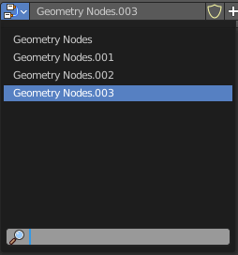
Data Browser
The list of available geometry node trees in the scene.

Edit box
The name of the current active geometry node tree. Here you can also rename the node tree.

Add Fake User
Wit this button you assign a fake user to this selected geometry node tree.
Data, like node trees, that is not longer linked to anything else gets removed when you save and reload a scene. Bforartists has the concept of fake users to go around this behavior. An image with a fake user is in fact linked to something. And so it is not lost when you save and reload the scene.

User
The number of users that uses this data. Data with a user number of 0 will be removed with closing Bforartists.

Add
Add a geometry node.

Remove
Removes the geometry node tree. To delete it completely you need to purge it. See Fake user.

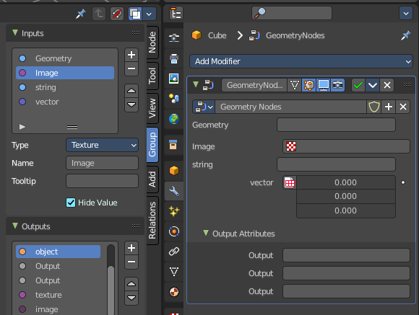
Custom Inputs and Outputs
In case you define custom inputs and outputs in the geometry nodes editor, then these inputs and outputs also shows in the modifier.

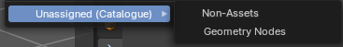
Unassigned (Catalogue)
Custom modifier assets. This menu item shows when you for example add a geometry node, and apply it. Then this applied node tree goes into this menu which allows you to reuse it. The term non-assets is a label, and no custom asset.

